Jenkins notes and handy workarounds –

Allowing Jenkins to interact with the desktop

1. If you install Jenkins as a service, note that the service would not interact with the UI (i.e. show your browser running and various UI interactions with it). This is in spite of the fact that you have checked “allow service to interact with the desktop” in the service’s settings in the MSServices console.
2. To work around the problem, I download the Jenkins .war file and ran Jenkins through the console. Copy the war file to a desktop folder , from the CLI goto the folder and run the below command –

Java –jar Jenkins.war

Note – You need Java preinstalled

Getting Jenkins to talk to your GitHub repository

1. Have the https link to your GitHub repo handy
2. Install Git on your PC (required even if you don’t use it and use GitHub rather)
3. Add path to Git exe in Jenkins …

Jenkins -🡪 Manage Jenkins 🡪 System Configuration

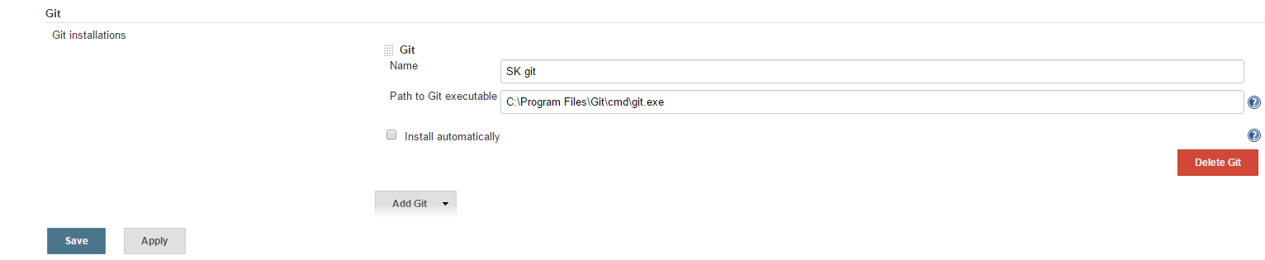

1. Now in your job configure which a link to your GitHub repo



1. Add Git credentials and mention which branch you want to check out

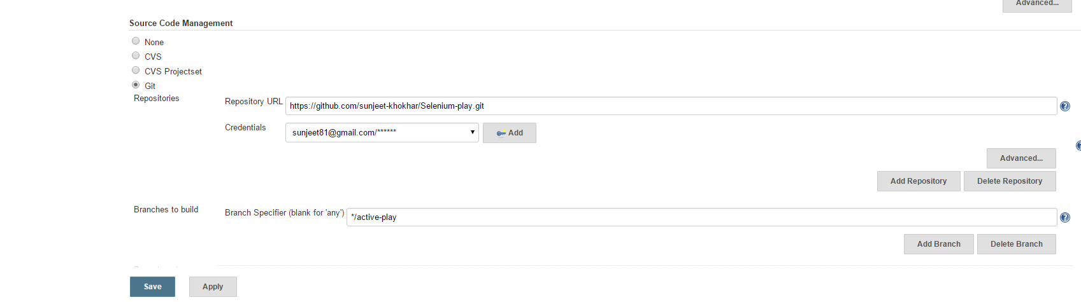

1. Mention which sub-directory (relative) to the workspace you want to check out your code into

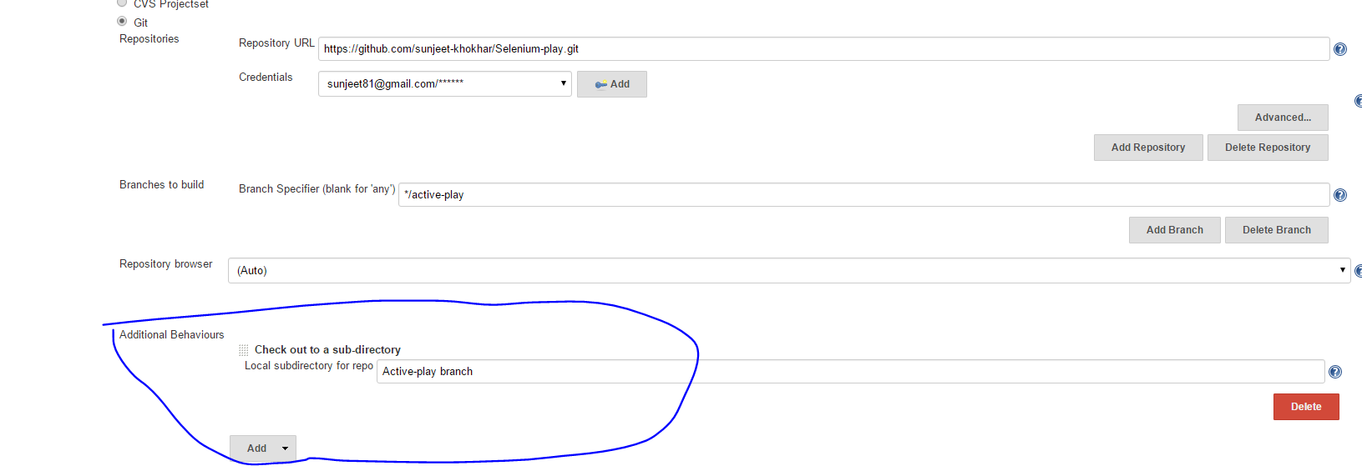

1. Check you connection with GitHub now

Got Jenkins home 🡪 Manage Jenkins 🡪 Configure system

And press the test credentials button 🡪 check “test basic connection to GitHub” and press “connect to api” button , it must succeed !

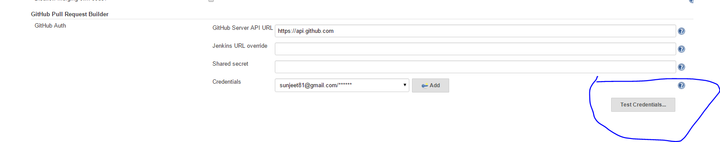

Now if you run this job and if it runs successfully, it will reach out to your git hub repo branch and check out the code to your local drive